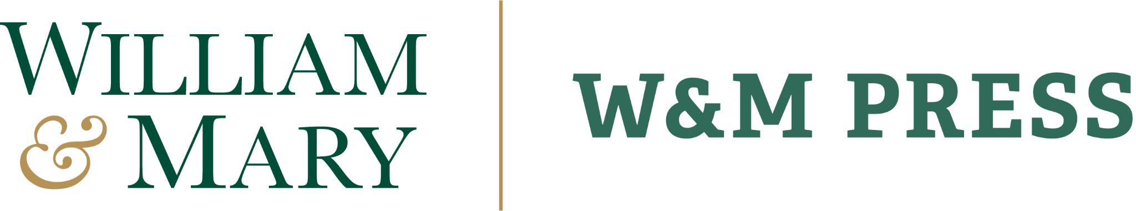

Acquisition Policy & Publication Process

Purpose
The purpose of this acquisition policy is to guide the selection, evaluation, and publication of high-quality, open-access curriculum materials that align with the educational mission of William & Mary. We aim to support faculty, staff, and students by providing accessible, innovative curriculum resources that enhance teaching and learning across disciplines and bridge barriers.

Scope of Acquisitions
William & Mary University Press specializes in publishing curriculum materials that include, but are not limited to:
- Open access textbooks
- Course modules and syllabi
- Supplemental teaching resources such as workbooks and assessment tools
- Multimedia and interactive educational content
- Pedagogical research with direct classroom applications

Rights Retention & Licensing

Rights Retention
Authors retain copyright to their works. The Press is granted the non-exclusive right to publish, distribute, and make publicly available works in a digital format.

Licensing
All acquired materials must be openly licensed (e.g. Creative Commons), except for the CC ND (No Derivatives) component, to ensure free and unrestricted access, adaptation, and distribution. A CC ND license may be applied in unique circumstances but require consultation and approval by the Press.

Selection Criteria
To be considered for publication, submitted works must meet the following criteria:
- Relevance & Alignment: must align with current educational standards (for COLL programs) or with area of expertise in a future course
- Scholarly Quality: must be well-researched and pedagogically sound

Submission & Review Process

Proposal submission
Authors can approach the press via email or by completing our submission form.

Initial consultation
Prospective authors meet with the editorial team to discuss and gather further details about the work and how it aligns with W&M Press and W&M’s curriculum.

Initial evaluation
The editorial team assesses the submission for alignment with the Press’s mission, selection criteria, copyright and design considerations, and feasibility to create the work.

Editorial decision
The Press will accept, request revisions, or reject the submission.

Production
The publication timeline, including manuscript delivery date, is determined after discussion with the author. Each author will complete an author agreement. Adjusting the manuscript delivery date requires consultation with the editorial team.

Accepted works undergo final editing, typesetting, formatting, accessibility review, and distribution assessment prior to publication. At this time, the Press does not cover the costs of hiring an editor to review completed works.

Publication
Published works will be delivered as a Pressbook with EPUB and PDF files deposited into ScholarWorks and made available on the Pressbook platform. The Press will ensure that each digital version of the published work meets accessibility standards.

When appropriate, print copies of the works will be ordered for inclusion in the William & Mary Libraries collection, preserved in the Special Collections Research Center, and given out to donors.

A print on demand feature will be added to each Pressbook instance at the request of the author.

Dissemination
Upon completion Pressbooks are made public in the W&M Press Pressbooks Catalog, https://viva.pressbooks.pub/catalog/wmpress.

Beyond the Pressbooks website, works will be deposited into other OER repositories, including Open Textbook Library, OER Commons, Teaching Commons, & MERLOT.

Additionally, a “Diving into Faculty Scholarship” blog post about the work will be added to the W&M Libraries website, and William & Mary Libraries External Relations will distribute a press release about the work. While not guaranteed, in consultation with External Relations, WM Libraries might hold a book talk for the publication when possible.

Ethical Considerations
All material must adhere to ethical publishing standards, including proper attribution, avoidance of plagiarism (including self-plagiarism), and adherence to open-access licensing.

The Press encourages collaborative authorship (including students), contributions from diverse voices within W&M’s educational community and external partnerships.

If AI is used in the creation of any element of the OER, authors must include an AI Declaration Statement in their work. WM Press will provide a template to create this declaration for authors.

Revision and Sustainability
Published materials will periodically undergo a review and update to ensure continued relevance and accuracy. Authors may collaborate with the Press on revisions, adaptations, and expansions of existing materials.

The Press will deposit each publication in AP Trust for long-term preservation.

Policy Review Schedule
The William & Mary University Press Acquisition Policy and Publication Process will be reviewed, updated and revised every 3 years, unless revisions are needed ahead of the planned review cycle.
This policy was last updated September 24, 2025 and is licensed under CC BY-NC 4.0

